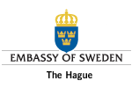
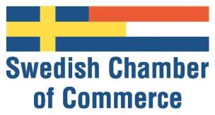
Application Form for the Swedish Chamber
Annual Achievement Award
Nomination Criteria
Nominated Companies Should:
- Have a Swedish mother company
- Meet high standards of Innovation and Sustainability in their operations
- Be able to show a successful achievement related to growing or driving export for Sweden during the past year.
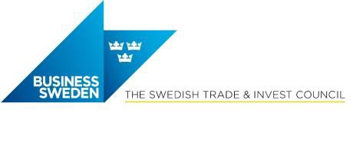
- Have a solid financial base and positive performance on the Dutch market
- Not have been rewarded with the Swedish Chamber Export Prize for the past 5 years.

Please send your application, per e-mail, before October 25, 2018 to:
info@swedishchamber.nl

Company details

Name Address
General Manager Phone number
Fax | Email www
Swedish Mother Company Year of establishment in NL

Nominator

Company Name Title/Function Phone number Fax | Email

Turnover in NL (M EUR) (if applicable)

2013: | 2014: | 2015: | 2016 F:
Profit in NL  2013: | 2014: | 2015: | 2016 F:

Number of employees in NL

2013: 2014: 2015: 2016 F:

Company overview

Backgrou n d to th e estab lish ment in N L (wh en /how):

Vision & mission on the Dutch market (why):

Service/product offering on the Dutch market (what & to whom):

Motivation for the nomination

Su stain ab ilit y & In novation

Special Achievement

Financial Performance

Success case(s) / Investments / Rewards / Other

